Cloud Migration with ORM stack

Contents

1. Introduction 3
2. Workflow diagram to deploy the stack 3
3. Create stack for Cloud Migrations 4
4. Plan the Job 7

Introduction
The Oracle Cloud Migrations service automates the migration of virtual machines from on-premises environments to Oracle Cloud Infrastructure (OCI). Using a simple managed connection with your data center, user can discover assets capable of migrating, group source workloads into migration projects, schedule data replication, and launch the migrated virtual machines to OCI.
Pre-requisites:
- inventory_asset_ocid
- replication_compartment_ocid
- snap_shot_bucket_name
- boot_volume_ocid

Workflow diagram to deploy the stack

Below diagram shows how the Terraform Artifact are applied in the OCI. While creating a ORM stack, using terraform deliverables Init, Plan and Apply is the flow to provision the resource in the OCI. We can have the deliverables in any of below.

- GitLab/GitHub Repo
- Bitbucket
- Can be in folder/.zip in the local disk
- Object Storage Bucket
- Can be in compartment
- Oracle provided Template


Create stack for Cloud Migrations

Go to OCI Console Developer Services Resource Manager Stacks select the compartment Create Stack

My Configuration Folder Browse Select the “cloudMigration” folder that contains the terraform Upload
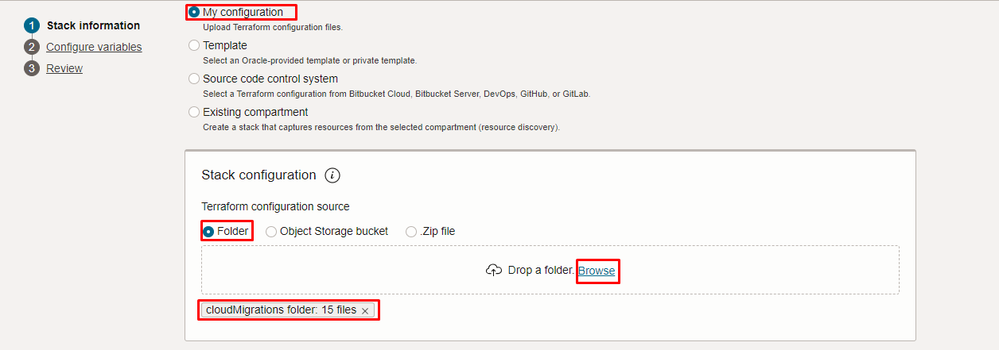
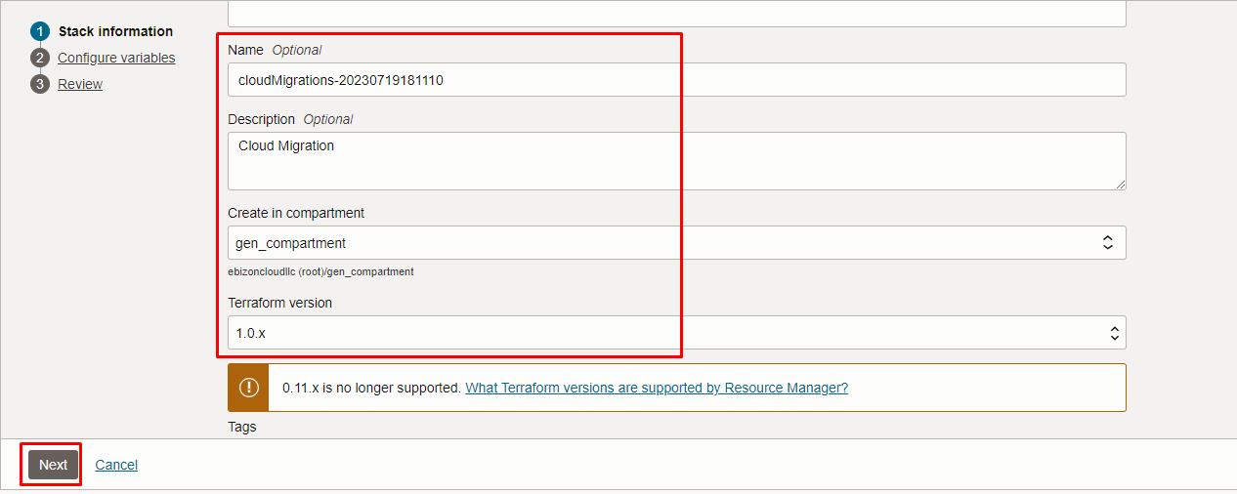
Click “NEXT”

Select the parameters as per the below screen,

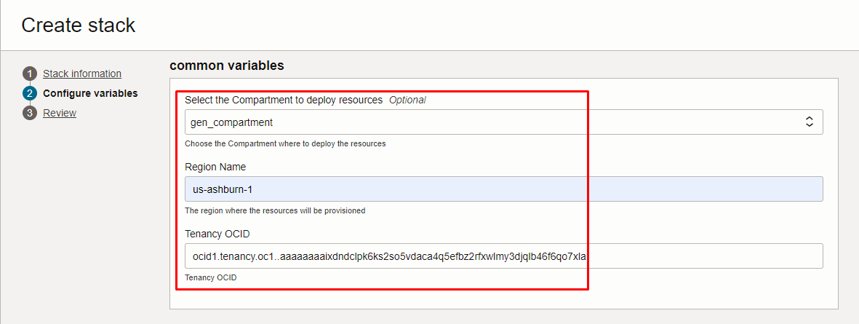
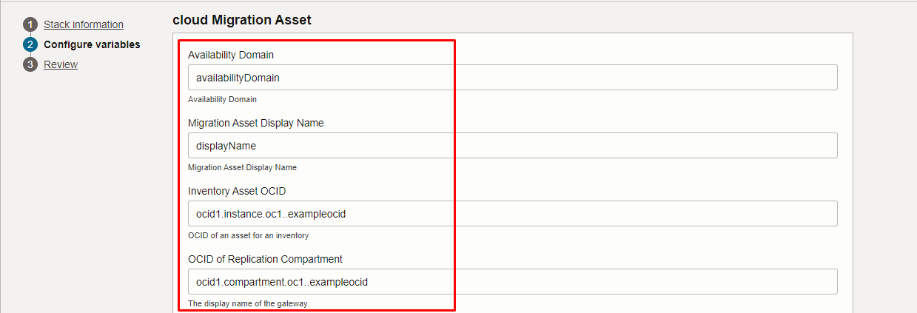
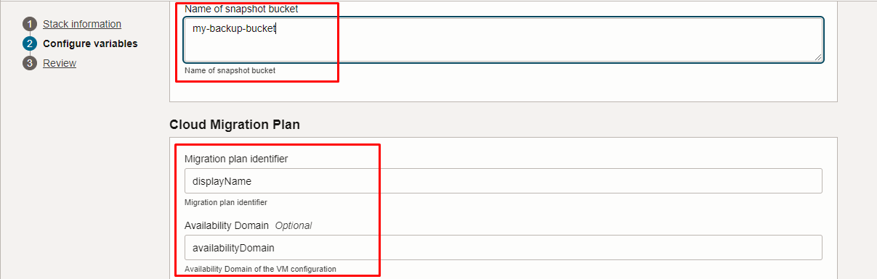
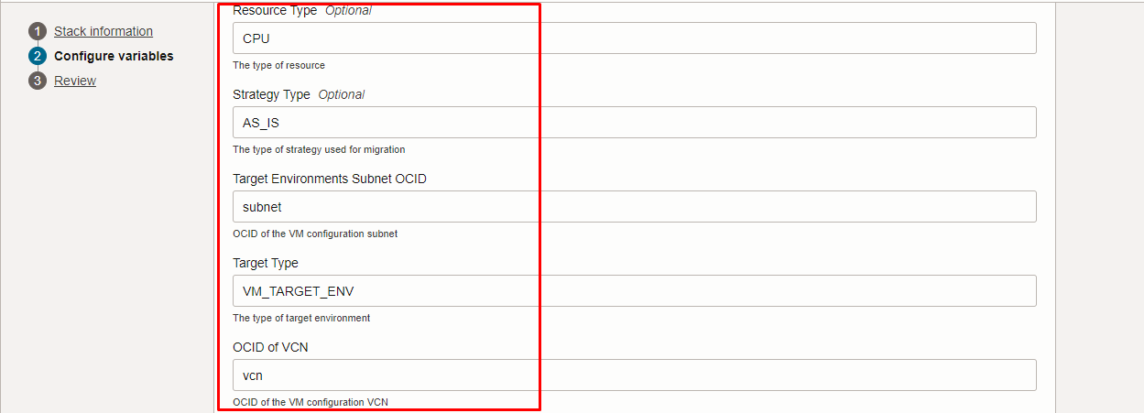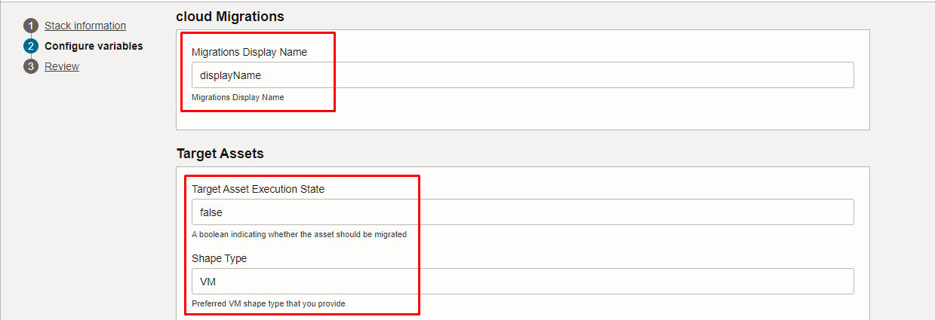
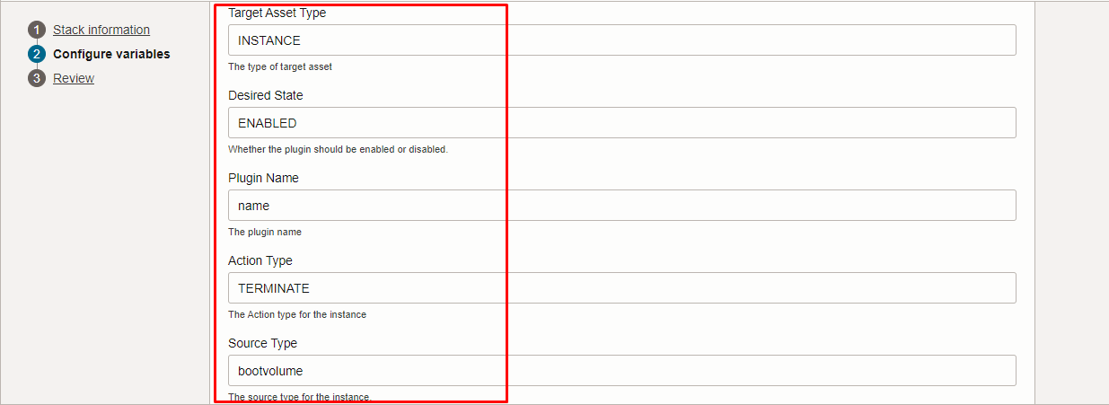
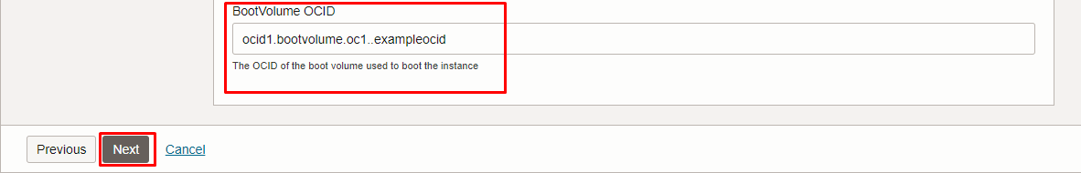
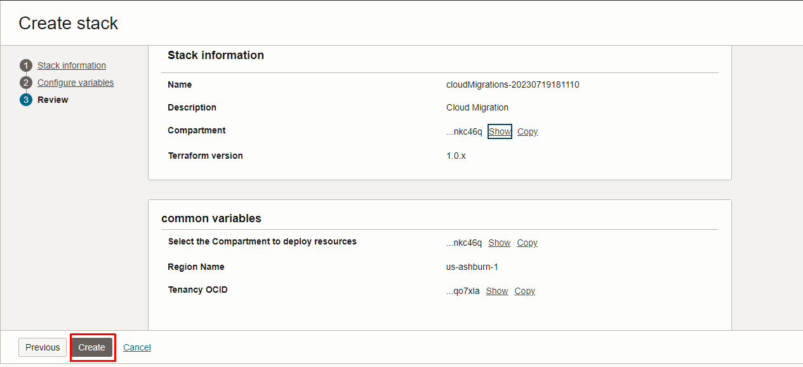

Click “NEXT” Click “CREATE”

Plan the Job

Click the “Plan”

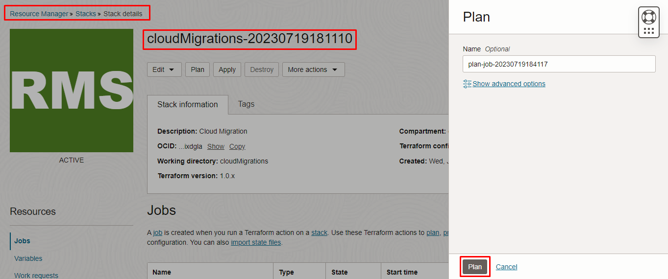

Verify the Plan is successful.
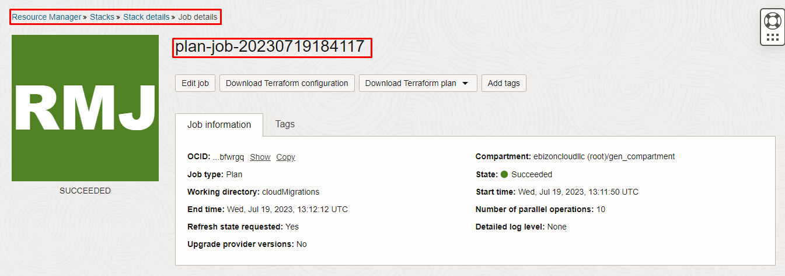
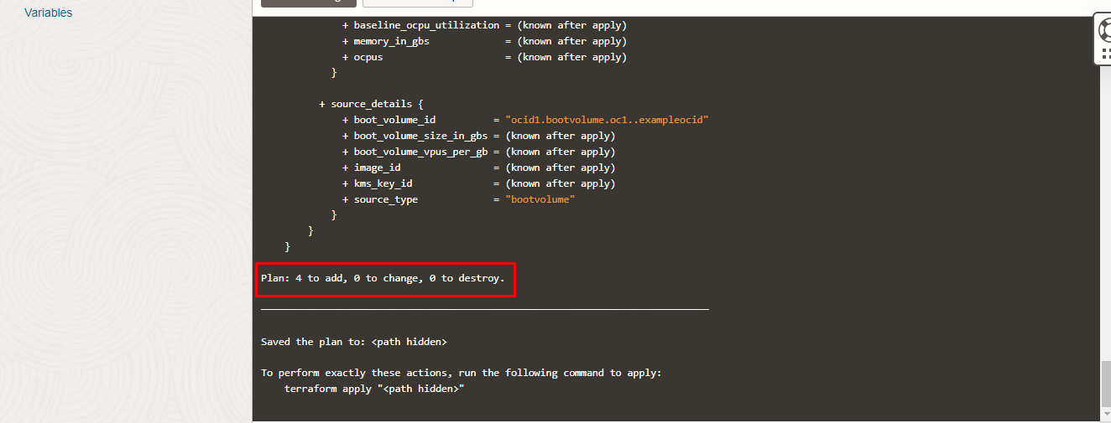

#END#

